OUTDOOR CHURCH
in the field next to West Anstey Church
for all the family, in all weathers!
Every fourth Sunday of the month
between 11am – 12 noon
... wear suitable clothing!
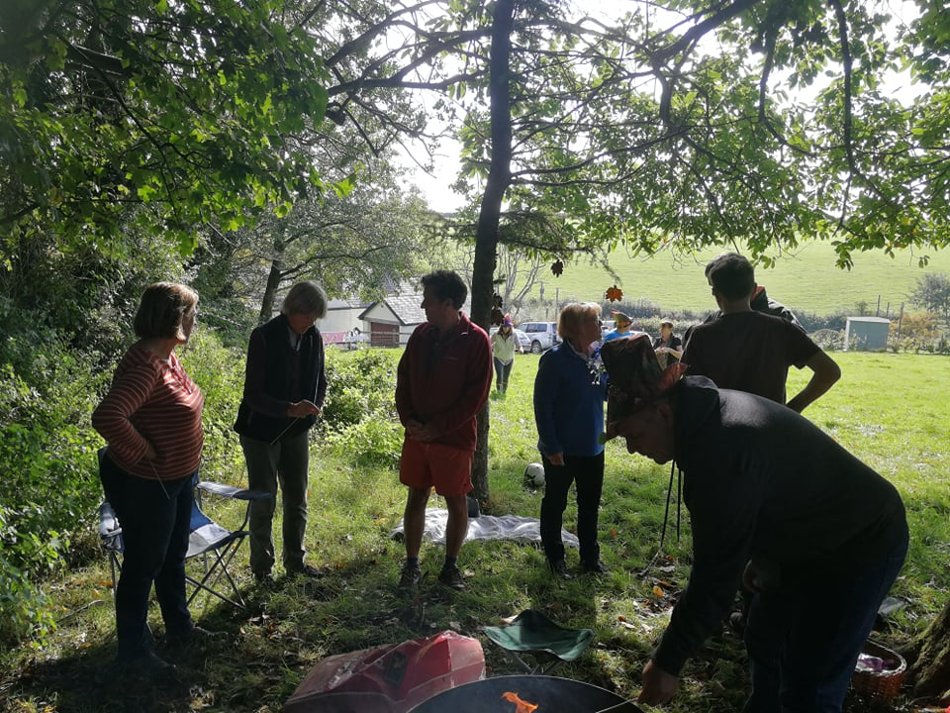

O

Future Dates:
Sunday September 25th (Harvest)
Sunday October 23rd
Sunday November 27th
December (date tbc) (Christmas ‘Outdoor Church goes Inn’)

