Every fourth Sunday of the month, in a field next to West Anstey Church, there is a safe place - where families and children can gather, where noise does not matter. This is where community is made round the firepit, laughter and chat, children running in the field and playing games, praying in God’s creation, appreciating the beauty of the changing seasons. This is OUTDOOR CHURCH. A time of freedom, fun and faith, a place where all are welcome, all are welcome.

You will find us on the periphery
In the land of the mapless unknown
You will find us at the edges
Where the wild things grow
You will find us in the liminal space
Where no one knows what to expect
You will find us where the sea meets the shore
And no one knows what will wash up next
You will find us among the hedgerows
Gathering what delights are growing there
You will find us with the bees and butterflies
Connecting over here with over with there
You will find us on our knees
With the beetles and the ants
Living all together
Without a lot of thanks
For our humble jumbled life
And our muddy handed style
But we would invite you
To come a stay a while
In the land where the wild things are
And the place where the periphery reigns
You may learn things here that serve you
When you return to your pathed way.
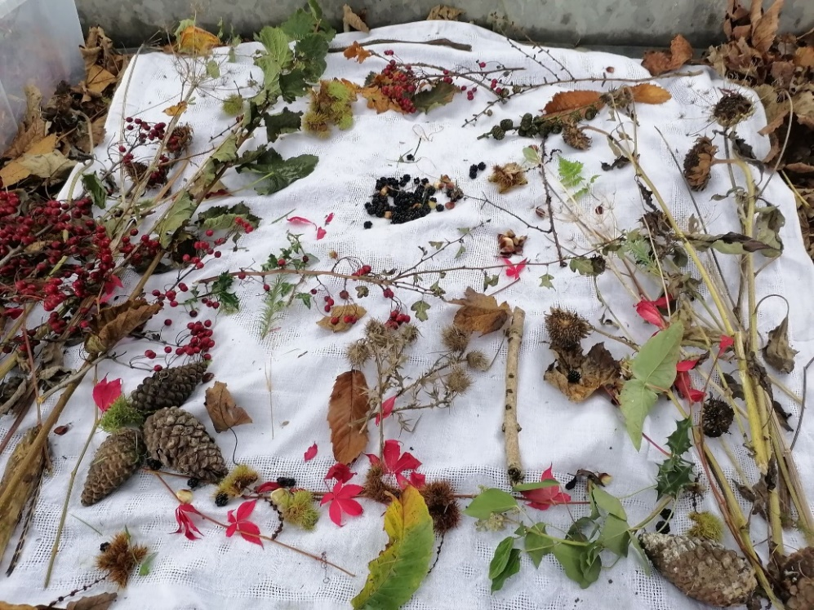
Anon

